Computer Networks (CS303)

Assignment - 6

**U19CS012**

1. Create **Bus, Ring, Star** and **Mesh** topology in *Cisco Packet Tracer* to understand the working of all the networking devices and networking media. Do take screenshots of topologies and add appropriate labels in the topology.

**A.) Bus Topology**

* All data transmitted between nodes in the network is transmitted over this **common transmission medium** and is able to be received by all nodes in the network simultaneously.
* A signal containing the address of the intended receiving machine travels from a source machine in **both direction** to all machines connected to the bus until it finds the intended recipient.

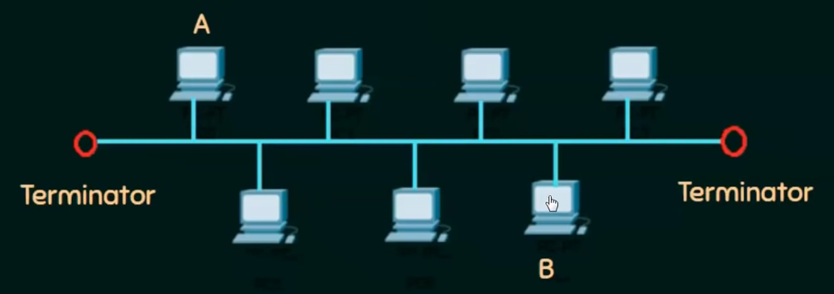

**Procedure:**

1.) Connect 4 End devices in Bus topology using 4 switches as shown below.

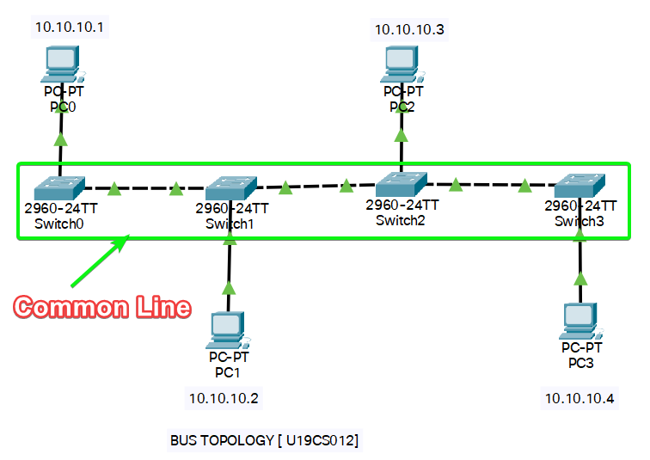

2.) Configure IP Address of Each End Device as Shown.

3.) Lets Check the Connection using Pin Command. [From 10.10.10.1 to 10.10.10.4]

**Simulation**



[<https://vimeo.com/600911484>]

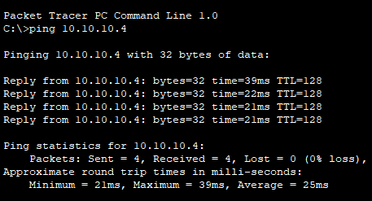

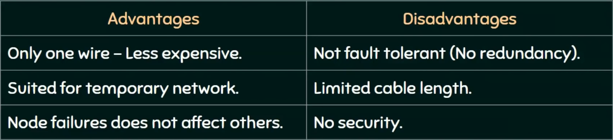

**B.) Ring Topology**

* A Ring topology is a bus topology in a closed loop.
* Peer-to—Peer LAN topology.
* Two connections: one to each of its nearest neighbors.
* Unidirectional.
* Sending and receiving data takes place with the help of a TOKEN

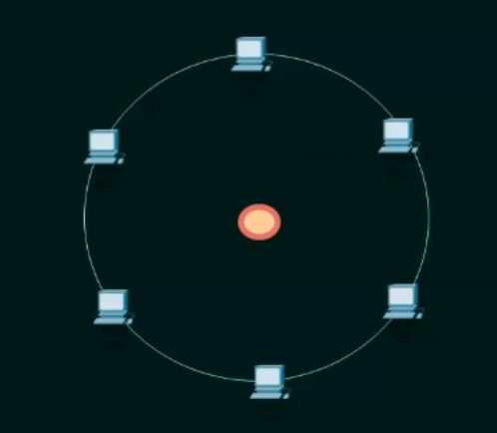

**Procedure:**

1.) Connect 4 End devices in Ring topology using 4 switches as shown below.

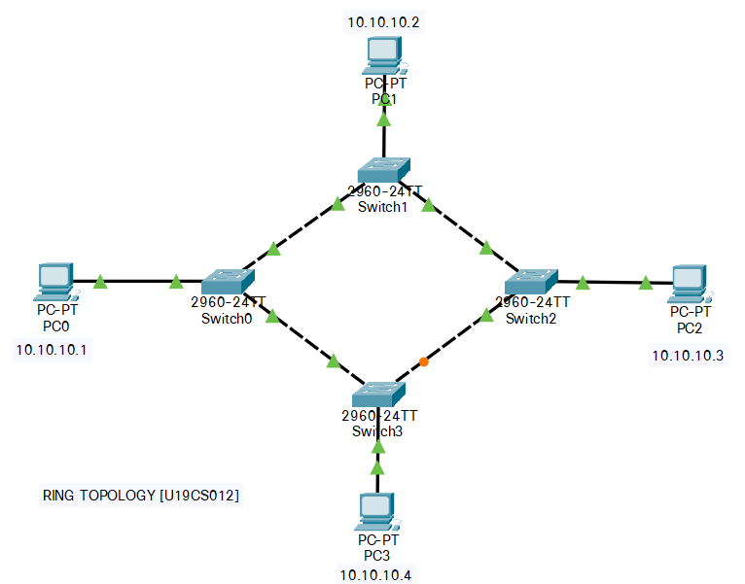

2.) Configure IP Address of Each End Device as Shown.

3.) Lets Check the Connection using Pin Command. [From 10.10.10.1 to 10.10.10.3]

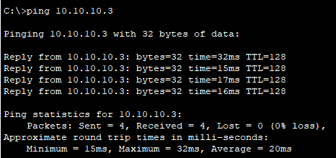

**Simulation**



[<https://vimeo.com/600939073>]

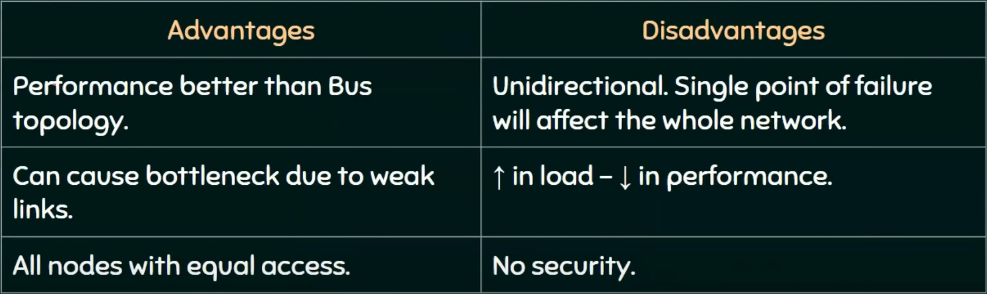

**C.) Star Topology**

* Every node is connected to a central node called a hub or switch.
* Centralized Management.
* All traffic must pass through the hub or switch.

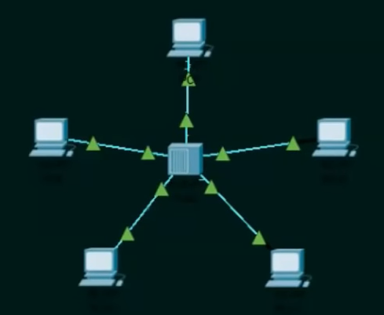

**Procedure:**

1.) Connect 5 End devices in Star Topology using 1 switches as shown below.

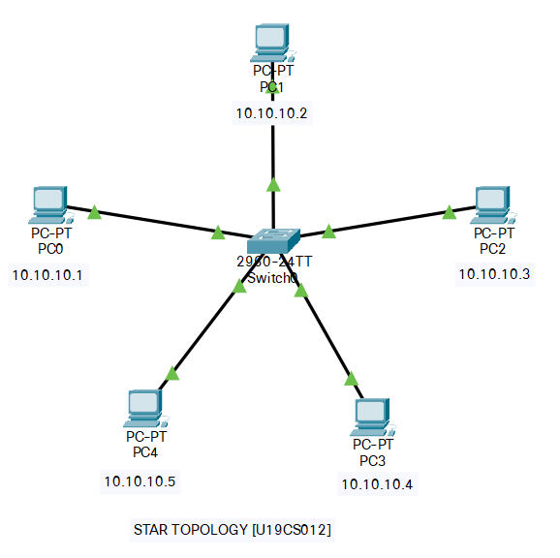

2.) Configure IP Address of Each End Device as Shown.

3.) Lets Check the Connection using Pin Command. [From 10.10.10.1 to 10.10.10.4]

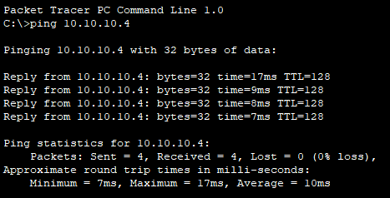

**Simulation**



[<https://vimeo.com/600947146>]

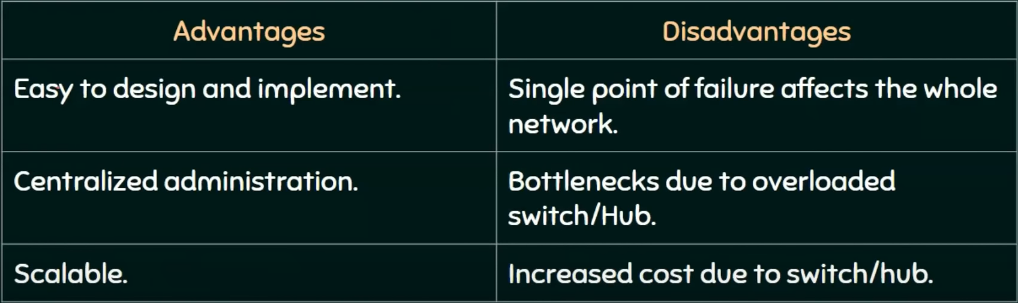

Extra [Extended Star Topology]

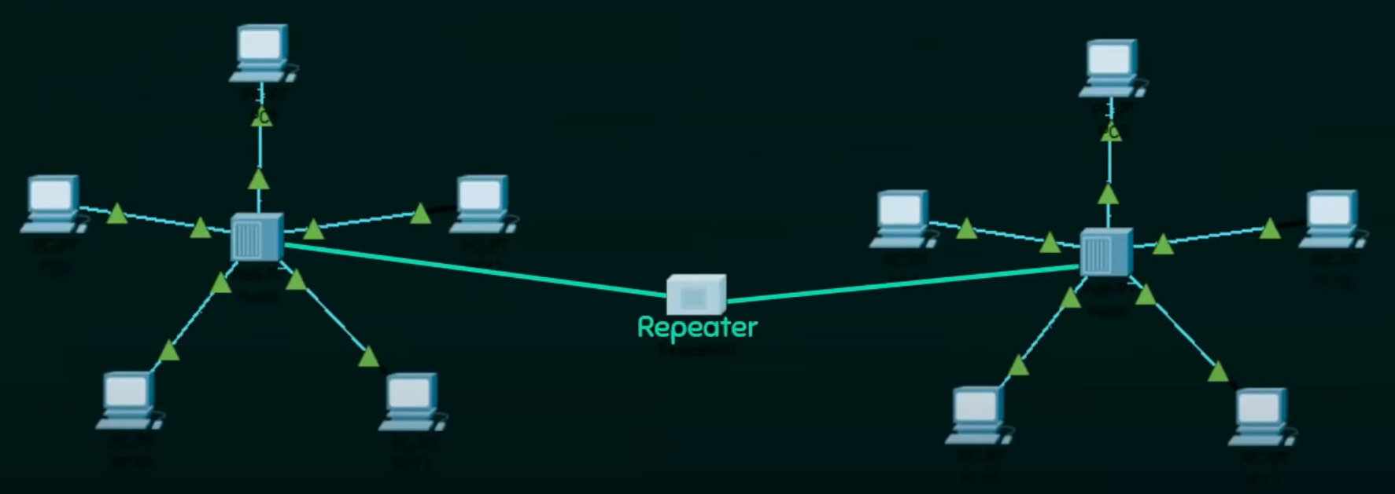

**D.) Mesh Topology**

* Each node is directly connected to every other nodes in the network.
* Fault tolerant and reliable.

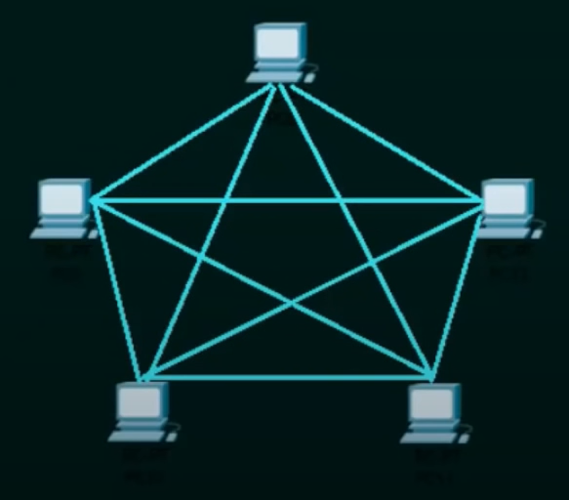

**Procedure:**

1.) Connect 4 End devices in Mesh Topology using 4 switches as shown below.

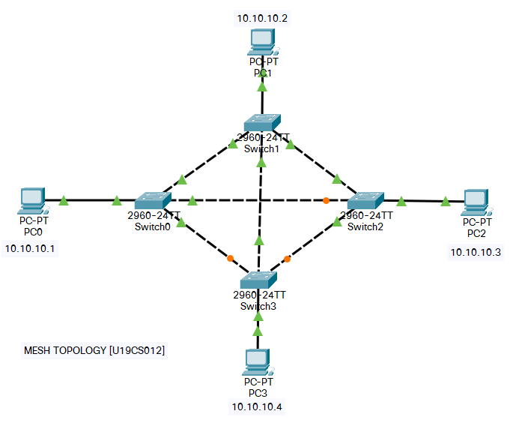

2.) Configure IP Address of Each End Device as Shown.

3.) Lets Check the Connection using Pin Command. [From 10.10.10.1 to 10.10.10.3]

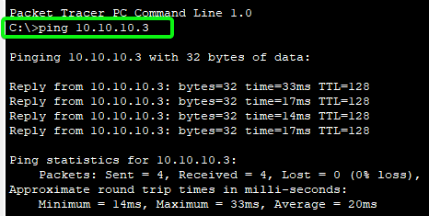

**Simulation**



[<https://vimeo.com/600952441>]

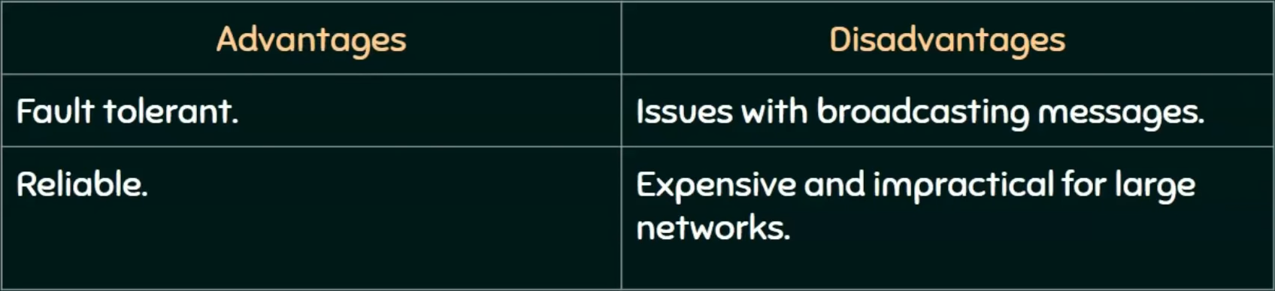

SUBMITTED BY: BHAGYA VINOD RANA [**U19CS012**]